TraceTool Viewer Documentation

Licences information.

HomePage : http://www.codeproject.com/csharp/TraceTool.asp
Download : http://sourceforge.net/projects/tracetool
TraceTool is based on the idea of the GDebug program , see http://www.gexperts.org

You are free to distribute the viewer (GPL) and to incorporate the library (LGPL) in your product (commercial or not).
The only thing you can't do is to sell the viewer (or a modified version) and the API as a tracing solution.

What is TraceTool ?

TraceTool is a Trace system composed of 2 parts:

- A framework (Dot net, Java, C++, ActiveX and Delphi for window).
See the corresponding API documentation.
- A viewer, written in unmanaged code (Delphi) that displays multiple kinds of traces :
  - The trace frameworks.
  - Caught OutputDebugString messages.
  - Event log
  - Last lines of text files, like Unix Tail –f command.

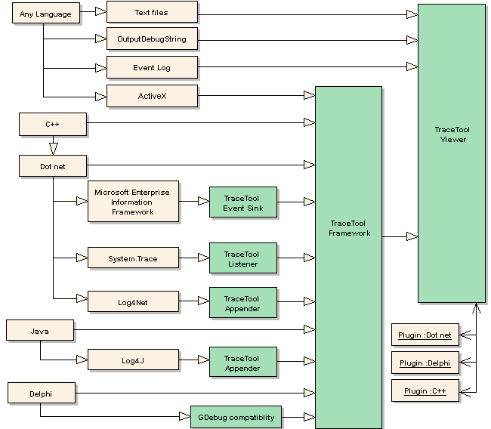

Receive messages from the client’s framework.
The client framework sends traces in the tree view. Multiple windows allow you to separate messages (exceptions, database,…)
See the “My trace window” tab in the following screen shot.
The viewer is automatically lunched by the client API. But if you want to use the socket mode (the case for Java application), you MUST run it before sending traces.

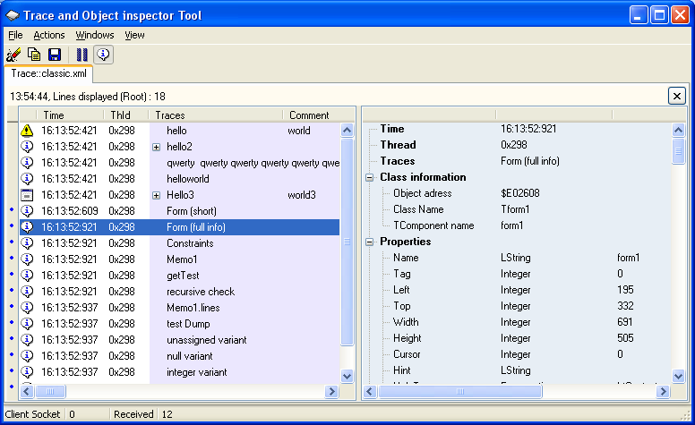

A small blue dot on the gutter indicate the presence of additional information available for the trace.
The “View Trace Info button” shows or hides the Trace info pane
You can pause messages (messages are lost), copy selected lines to the clipboard, delete selected lines, clear all or save all traces to a text file or to an XML file. (See screen shot) .

Text export use the same rules as clipboard export.

You can close trace window, as well as the main trace.
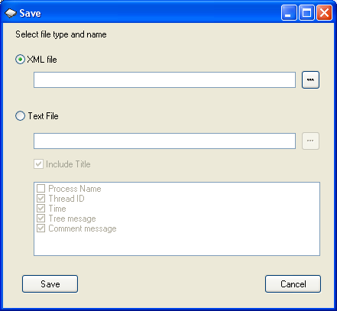
To redisplay it, click on the “Windows / Show Main traces” menu.

Catch System OutputDebugString messages

To display the ODS window, click the “Windows / Show OutputDebugString” menu. Depending on the language you use
(Delphi , C sharp or other), traces are re routed to the IDE. This window also catches some system traces.

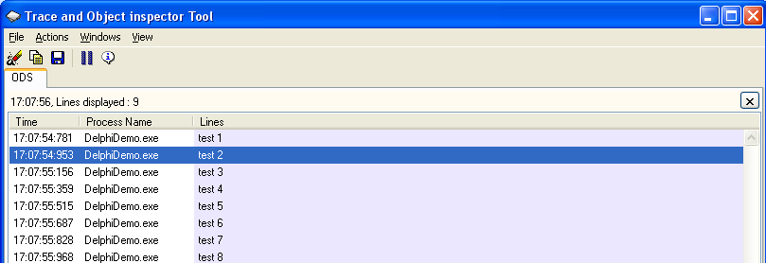

Event Log

The “Window/open Event Log” menu let you monitor live traces added to the various event logs (Application, security, system, or user defined file). Clipboard operations and export are allowed. Tips: Due to a W2K/XP Api bug, some delay may happen.

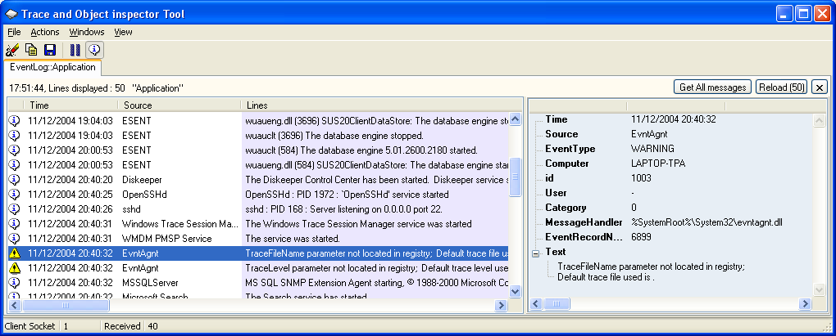

Display multiples ‘Tail’ content files.

To add a new “Windows / Open Tail file…” menu and select the file you want to watch. Clipboard operations are allowed but export is disabled, since traces are already stored in the file. You can delete unnecessary traces or reload last lines.
The number of displayed lines is also specified in the Option menu.

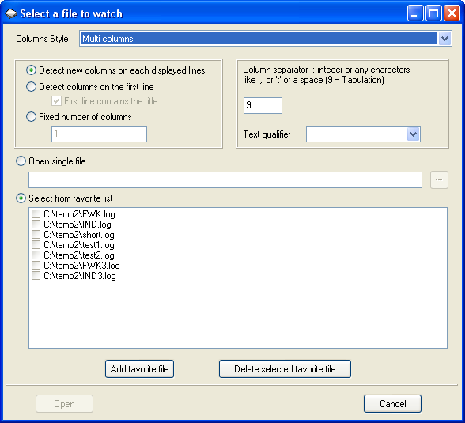

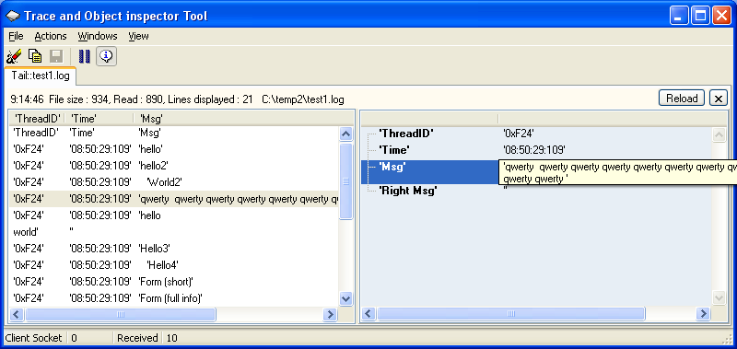

Viewer configuration (View Option menu)

The general option :

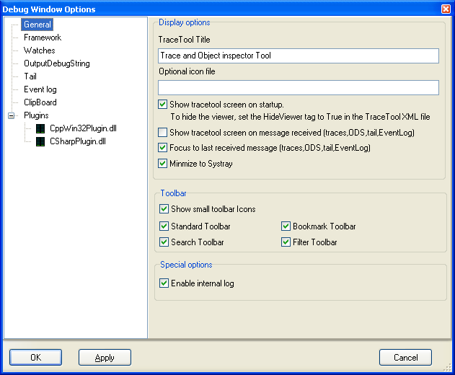

TraceTool Title:
The Title of the program can be changed to reflect enterprise integration.
Show on startup:
When TraceTool is launched, the user interface can be displayed or hidden.
If you want to completely hide the viewer (just keeping the traybar popup menu to close it), you must change
the tracetool.xml file by hand (because it’s too dangerous in the user interface) and change the <HideViewer> tag
value to true. This is usefull in a production environment where you want to hide your traces to the end user.
This option should be used with the setLogFile function in the WinTrace API to set a log file for each trace window.
Show on message received:
If the user interface is hidden, new messages can automatically display it
Focus to last received message:
Highlight the last message received. If not set, messages are added on bottom and you must scroll down.
This lets you watch a particular trace without having to pause.
Toolbar:
Change the Toolbar Icon size. You can show or hide part of the toolbar like the “Search” icons.
Enable internal log:
Let tracetool debug itself.
If the option is set (default), some internal traces can be added to the 'c:\TracetoolInternalLog.txt' file.
Messages can also be added to the “Internal Trace” windows.
Please post comments on: http://www.codeproject.com/csharp/TraceTool.asp if you see that traces.

Optional Icon file:
This option let you change the icons used to display warning, error , debug and other icon in the gutter.

Each Trace has an associated Icon (use TraceNodeEx API to modify the index of the icon)

Possible Icons  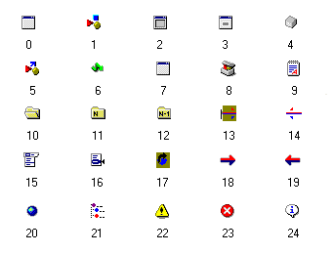 | Some icons have predefined constant defined (see API)  CST_ICO_FORM 0  CST_ICO_COMPONENT 1  CST_ICO_CONTROL 3  CST_ICO_PROP 5  CST_ICO_MENU 15  CST_ICO_MENU_ITEM 16  CST_ICO_COLLECT_ITEM 21  CST_ICO_WARNING 22  CST_ICO_ERROR 23  CST_ICO_INFO 24

To change icons (16 by 16), modify the tracetool.bmp file (you can also add new icons)
Giving a non existing icon index will result in a blank space.

Framework options :

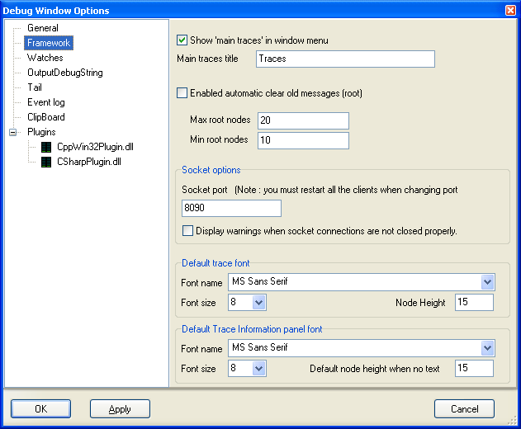

Show ‘Main traces’ in window menu:
In a production environment, you can hide the ‘Show Main traces’ item menu

Main trace title:
You can change the default Main trace title.

Auto clear:

To prevent TraceTool memory problems, the number of displayed messages can be limited.
You can for example have a limit of 2000 messages and let the system delete the first 500 messages.
In that case, specify 2000 as the ‘Max’ and 1500 as ‘Min’.

Socket port:
When the client API use socket, you can change here the listening port (Must be the same port on the client API).
Default is 8090. Don’t forget to stop and restart the viewer if you change it.
If the client don’t close properly the connection, TraceTool can add a warning message
(runFinalizersOnExit is deprecated in Java)

Fonts :
You can change the default font for framework windows traces and the associated Information Panel.
In case the Information Panel don’t contains text line, you must specify the default height.

Watches options :

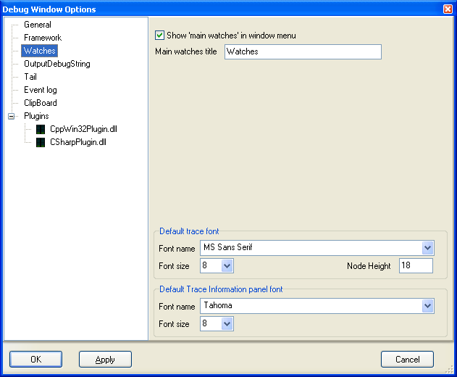

This short screen let you change the main watches title, Show or hide the ‘Main watches’ item menu and specify fonts
OutputDebugString options :

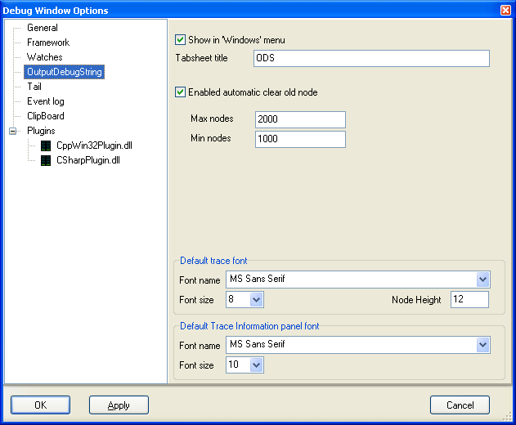

Provide the same kind of options as for the framework options.

Tail options :

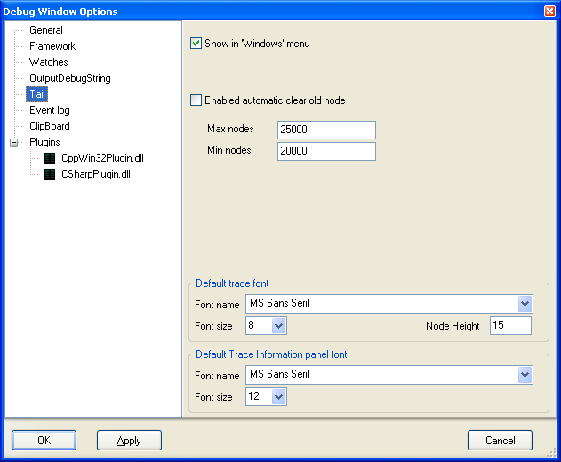

Provide the same kind of options as for the framework options.

Eventlog options :

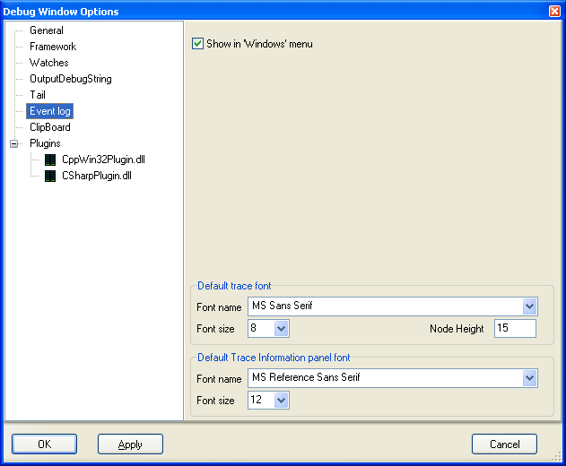

You can disable the “Windows” / Open event log menu and specify fonts.

Clipboard export :

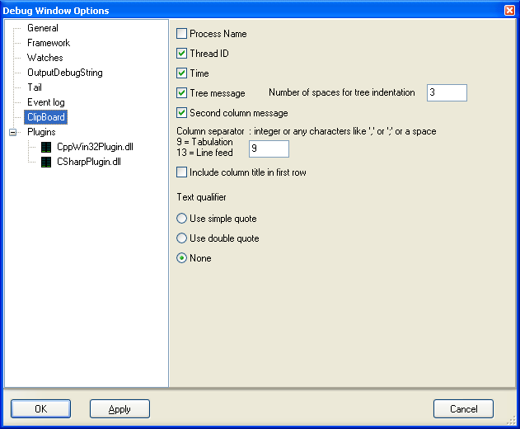

The Cut and Copy actions save selected messages to the clipboard. The user can determine how thes messages are formatted.
Plugins options :

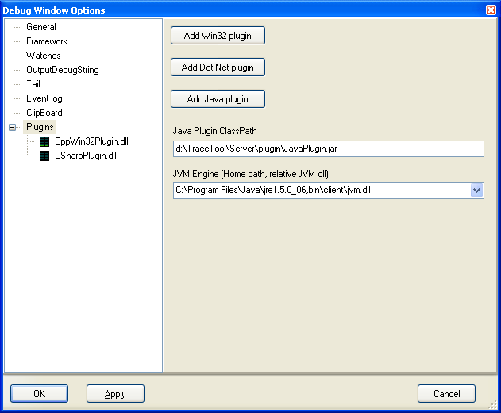

Tracetool can be extended with plugins. You can for example add clipboard history (see C++ sample), monitor hard drive activity,…
Plugins can written in Dot net, Delphi or in unmanaged C++.
Java is temporary removed in version 9. For java, you have to specify the class path and the JVM.

When a plugin is loaded, you can stop it, restart and remove from configuration.
The status of the plugin is displayed at the left of his name (or file if yet loaded)

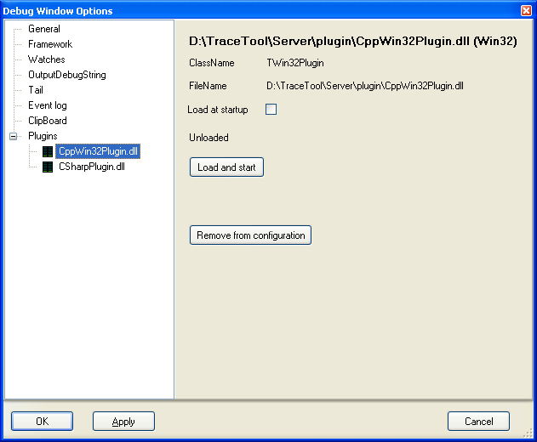

Viewer Installation

Here are all files used by the viewer:

TraceTool.exe | The viewer
TraceTool.xml | The viewer configuration file. If not present , this file is automatically created
TraceTool.bmp | You need to deploy this file if you want to change the default icon used in the viewer.  Can be removed if it's not the case.
TraceTool.exe.config | You need to edit and deploy this file only if you need dot net plugins and have multiple frameworks installed. Can be removed if it's not the case.
Plugin.zip | A collection of sample tracetool plugins.  Only the ClipBrdHistory.dll is a functional plugin that show clipboard history.  Others plugins are for framework demonstration.  This Zip file contains also wrappers for dot net and Java plugins :  - DotNetWrapper.dll : must be deployed only if you create dot net plugins.  - JavaWrapper.jar : must be deployed only if you create Java plugins.  Wrappers must be unpacked and copied at the same place as the viewer or in the plugin sub folder.

